Shumeng Gu

INLS 623

SCM project, stage 1

Requirement Gathering for miPad SCM System

This report focuses on establishing different system analysis models in order to provide thorough and detailed information about building a database which supports the supply chain of miPad production. Three parts will be divided in this report. First, I will introduce the general concepts of supply chain management system and how an effective system can contribute to the operations of corporations. Second, I will use different structure models to illustrate how miPad supply chain works, and analyze the merits and demerits of different model presentations. The last but the most important part will include a data flow model. Based on the data flow model, I will come up with the stakeholders the database systems, what attributes should we focus on, as well as what kinds of relationship exist between them.

1. General Introduction to SCM

A supply chain is a system of organizations, people, technology, activities, information and resources involved in moving a product or service from supplier to customer (Wikipedia). A supply chain consists of all parties involved, directly or indirectly, in fulfilling a customer request (Chopra and Meindl, 2004). Because supply chain is the essential bridge connecting end customers and manufacturers, manufacturers and suppliers, effective management of supply chain can inevitably reduce cost, increase profit and improve competitiveness. Supply chain management (SCM) is the planning, organizing, coordinating and controlling of the product flow, business flow, finance flow as well as information flow process of supply chain. It spans all movement and storage of raw materials, work-in-process inventory, and finished goods from point of origin to point of consumption. In this regard, its goal is to improve the general operational speed of the supply chain and increase its profits and added values. That is why SCM is closely related to management information system and entrepreneur resources planning management.

We can assume that Mapple is a large size corporation and its miPad product has a large number of end customers throughout the world. Therefore, the supply chain of miPad should at least include the following actors (stakeholders): sub-component manufacturers (since miPad is a hi-tech multi-touch electronic devices, we assume there are multiple layers of suppliers), component manufacturers, miPad manufacturers, wholesalers (online store retailers), retailers, end customers, etc. What is more, it also should include warehouse, logistic services, and customer services. It is worthy to note that customer services should be regarded as an integral part of supply chain (although it will not be included in the database system, as discussed below), because it is a direct way to get the customers’ feedback and accordingly improve the business strategy and optimizing for more effective supply chain in the future.

2. Supply Chain Structure Models

As shown below, there are two ways to express the structure models of a supply chain. One is the chain model (Figure 1 and 2).

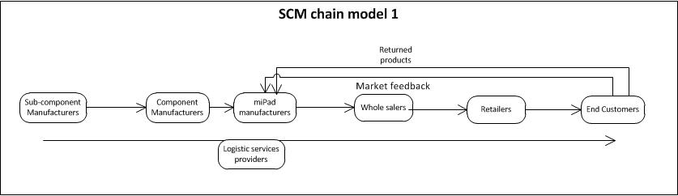

(Figure 1: SCM chain model for the distribution via retailers)

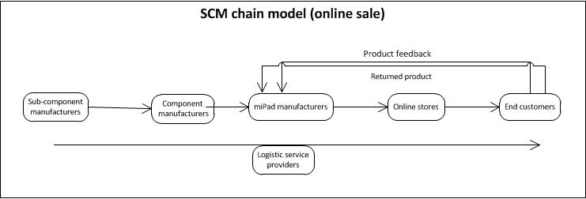

(Figure 2: SCM chain model for the distribution via online stores)

This kind of model is able to clearly demonstrate the concise structure of a supply chain. Initially, the miPad manufacturer, namely Maple, decide to produce its miPad products, so it processes an order to buy components for the product, such as LED displayer, audio system or CPU; when getting the orders, the component manufactures will communicate with the sub-component manufacturers to supply raw materials for those components such as diode, electric wire, etc. Then, the sub-component manufacturers would start to produce their products, which are transported to the upper level of manufacturers, and then the components will get to the manufacturing department of Maple. At this stage, the connection between suppliers and manufacturers has been completed.

After the Maple manufacturers manage to produce miPad, the goods will be distributed to different wholesalers. A state in the US may only contain one wholesaler, who would, after receiving the products, hand out to local retailers such as Wal-mart, Best Buy or Target for the final sale to the end customers.

For a multinational corporation like Maple, its suppliers, manufacturers and distributers are located in different regions or even throughout the world. Therefore, effective logistic services are essential. Also, the directly interactions between the customer and the manufacturers include product returning process (although in some cases this situation happens between the customers and the distributers) and customer feedback. The manufacturers are also supposed to know the market demands of their products in order to build respective strategies.

Another way of showing the structure of the supply chain is the network model, as shown in Figure 3 below.

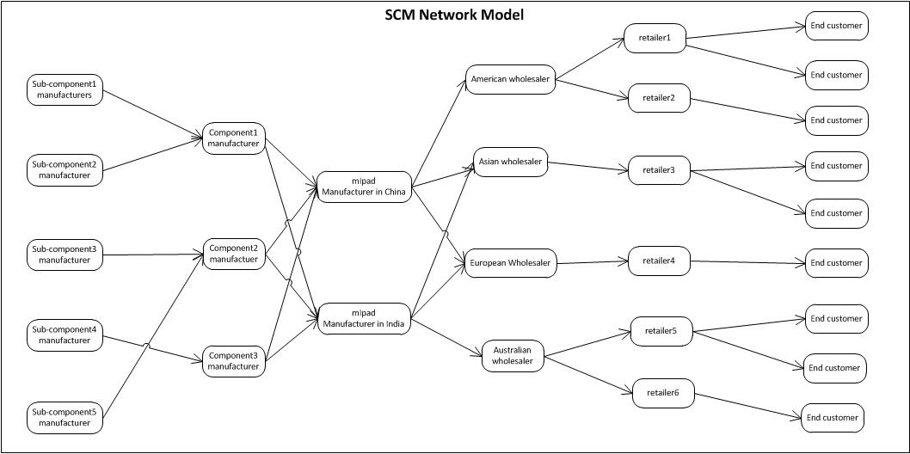

(Figure 3: networking model of the supply chain with the sale via retailers)

The main advantage of this structure model is you can provide the detailed information in each stakeholder, and how they are interacting with each other. For example, in this example model, we can clearly see that sub-component1 and sub-component2 are produced for the purposes of building component1, and there are two manufacturers, which located in China and India, who provides miPad to wholesaler all over the world. As far as I am concerned, these detailed presentations of their interactions will be beneficial to build the SCM database, because it can show the relationships more vividly, and these relationships can serve as the incentives of foreign key or trigger establishment.

Yet, this model is far too complicated if there are hundreds of individual entity for each stakeholder, because it would be really hard to depict them with details with models.

3. Data Flow Model and Requirements for Creating SCM Database System

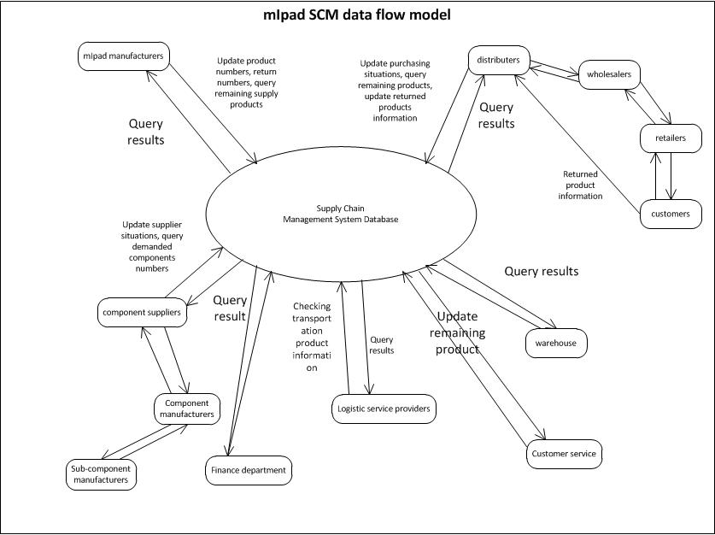

(Figure 4. Data flow diagram of miPad supply chain management)

Above is a general data flow diagram which contains all kinds of stakeholders I can come up with. However, when designing a database system, I think there is no need to include the finance department, customer service and the end customer information. It is because for one thing, these three entities are only related to a specific entity, but have little connection with the supply chain system as a whole, and for another thing, inputting so much information inside the database is likely to cost unnecessary storage and increase the risk of operation anomaly. On that score, I believe the main stakeholders of the system should include manufactures, suppliers, distributers, transportation (logistic services) providers and warehouses.

First, for the manufacturers, they should be able to interact with the system in order to conduct the following activities: to view the components update situations from the supplier’s part, to update the newly produced goods amounts, to monitor the warehouse’s remaining products, to monitor the sale situations on the distributer’s parts, and to trigger alerts whenever the warehouse is out of stock, the suppliers are unable to supply sufficient goods, or the distributers sale too many or too less products. Second, the suppliers are supposed to conduct the following interactions: to check the demands of each component which are provided by the manufacturers, to monitor the remaining amounts of the components and update it, and to get notified when the manufacturers set an alert to them. Third, the distributers need to monitor the warehouse’s remaining products in order to better allocate the goods, to update the warehouse’s statistics whenever the goods are distributed, and to provide the market demand of the products as a reference to the manufacturers. Fourth, the warehouse needs to check the update from both the manufacturers and the distributer’s parts, and trigger an alert whenever it is out of stock or is about to out of stock, or the space is not enough for more goods, or something goes wrong with the currently stored goods. At last, for the transportation services providers, they should update the database whenever there is a transportation business, and the information should include the transportation is from which place to which place, the date of the transportation, the goods information, etc. In my opinion, this entity is particularly important, because it is a channel to connect with different entities. In addition, since Maple is a multinational corporation with stakeholders spreading all over the world, the transportation services should be regarded as the most integral process for its supply chain.

There should also exist some sub-database systems inside the suppliers (for example, between the sub-component manufacturers and the component manufacturers to enable successful information flow, and also between different levels of distributers). What’s more, any anomaly inside the supply chain should be noticed or prevented immediately, such as lack of supplied components, lack of in-stock products, or excessive products which are far more than what the market needs.

References:

1. Wikipedia, “Supply Chain” and “Supply Chain Management”

<http://en.wikipedia.org/wiki/Supply_chain_management>

<http://en.wikipedia.org/wiki/Supply_chain>

2. Chopra, Sunil and Peter Meindl. Supply Chain Management. 2 ed. Upper Saddle River: Pearson Prentice Hall, 2004.